MARKETPLACE RIDER
User Manual and Procedures Guide
Delivery Rider Edition

Mobile application
Product version 3.7
Draft for Team Review
Prepared 29 July 2026

Document Control
Document field | Value
Document title | Marketplace Rider User Manual
Role edition | Delivery Rider
Product and platform | Version 3.7 - Mobile application
Document status | Draft for Team Review
Document owner | Review Required
Approver | Team Lead / Product Owner
Classification | Internal draft until approved
Official support contact | Review Required

Revision History
Version | Date | Change summary | By
0.1 | 29 July 2026 | Initial delivery-rider draft based on supplied screenshots | Initial draft
0.2 | 31 July 2026 | Added tested sign-in and password-recovery workflows | Draft update
0.3 | 31 July 2026 | Implemented incoming request review, mapping, acceptance, and ignore workflows, role-specific Home dashboards, and fully tested delivery-attempt and COD completion workflows. | Draft update
Review Required: Confirm the product owner, release date, supported mobile operating systems, official support channel, login/recovery behavior, retry limits, COD process, and legal/privacy wording.

Contents
Document Control i
Revision History i
Contents ii
1. Introduction 1
1.1 Purpose of this manual 1
1.2 Intended audience 1
1.3 Document conventions 1
2. Product Overview and Requirements 1
2.1 What is Marketplace Rider? 1
2.2 Operating context 1
2.3 Requirements 2
3. Getting Started 2
3.1 Register a delivery-rider account 2
3.2 Sign in and recover a password 5
3.2.1 Sign in to Marketplace Rider 5
3.2.2 Reset a forgotten password 6
3.3 Navigate the app 10
4. Orders and Delivery Procedures 12
4.1 Review and respond to an incoming request 12
4.1.1 Review the request card 12
4.1.2 View the map and order details 13
4.1.3 Accept an incoming request 13
4.1.4 Ignore an incoming request 14
4.2 Pick up an assigned order 14
4.3 Deliver an order 15
4.4 View running orders and history 16
5. Return Procedures 16
5.1 Pick up a customer return 16
5.2 Return a product to a vendor or store 17
5.3 Return a product to the platform 18
6. Communication and Notifications 18
6.1 Conversations 18
6.2 Notifications 18
7. Profile and Preferences 19
7.1 Availability and profile 19
7.2 Language 19
7.3 Withdrawal methods 20
7.4 Delete account and logout 21
8. Wallet and Earnings 21
8.1 Wallet overview 21
8.2 Adjust payments 21
8.3 Review earnings 21
9. Interface and Status Reference 22
9.1 Primary controls 22
9.2 Important statuses 23
10. Security and Data Handling 24
11. Troubleshooting and Support 25
11.1 Diagnostic checklist 25
11.2 Common issues 25
11.3 Support information 26
Appendix A. Glossary 26
Appendix B. Pre-publication Review Checklist 27

1. Introduction

1.1 Purpose of this manual
This manual explains how an approved delivery rider uses the Marketplace Rider mobile application version 1 to register, manage availability, review orders, complete delivery and return activities, communicate with participants, and review account and earnings information.

1.2 Intended audience
This edition is for delivery riders working with the marketplace's grocery, food, pharmacy, and e-commerce services. It does not document administrator, customer, vendor, store, or warehouse operations.

1.3 Document conventions
- Bold text identifies an interface label, button, tab, or status.
- A Note provides a useful context.
- A Caution identifies an action that may affect money, order, or personal information.
- A Review Required notice identifies information that must be confirmed before publication.

2. Product Overview and Requirements

2.1 What is Marketplace Rider?
Marketplace Rider is the mobile application used by delivery riders in a marketplace supporting grocery, food, pharmacy, and e-commerce orders. The app provides registration, order and return tracking, communication, profile controls, withdrawal methods, wallet information, and earnings records.

2.2 Operating context
- The rider registers and waits for administrative approval before using the operational features.
- The rider uses Home, Request, Orders, and Profile as the primary navigation areas.
- Order screens may provide Chat, Call, and Direction controls for stores, customers, administrators, or platform locations.
- The app records order status, payment method, payment status, delivery attempts, return progress, and financial information.

2.3 Requirements
Requirement | Currently known | Review Required
Device | Mobile device capable of running Marketplace Rider | Supported Android/iOS versions
Network | Internet connection is required for current information and communication | Minimum connection or offline behavior
Account | Approved Marketplace Rider delivery-rider account | Session timeout and lockout rules
Permissions | Notifications and location/directions may be needed | Exact required mobile permissions
Files | Registration images support JPG, JPEG, or PNG under 2 MB | Other upload limits

3. Getting Started

3.1 Register a delivery-rider account
Goal: Submit a delivery-rider registration request for administrator review.
Prerequisites: A valid phone number, email address, password, delivery information, identity information, and permitted identity images.
Procedure
- Open Marketplace Rider and select the delivery-rider registration option.
- Enter the rider's first name, last name, email address, and phone number.
- Create and confirm a password containing at least eight characters.
- Optionally add a profile picture in JPG, JPEG, or PNG format under 2 MB.
- Read and accept the Terms & Conditions and Privacy Policy.
- Select Next.
- Select the delivery type: Freelancer or Salary Based.
- Select the delivery zone and vehicle type.
- Select the identity type: Passport, Driving License, or CNIC.
- Enter the identity number and add the required front and back identity images.
- Review the information and select Submit.
Expected outcome: The app confirms that the registration request was sent successfully and is waiting for administrator review.

If unsuccessful: Correct any highlighted field or file problem. Do not repeatedly submit the same registration. Contact the designated administrator if approval feedback is not received.

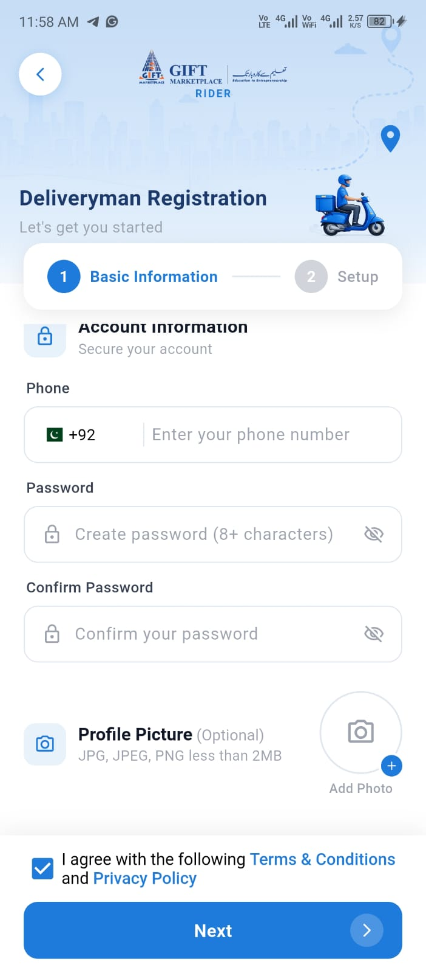
Registration - Basic Information
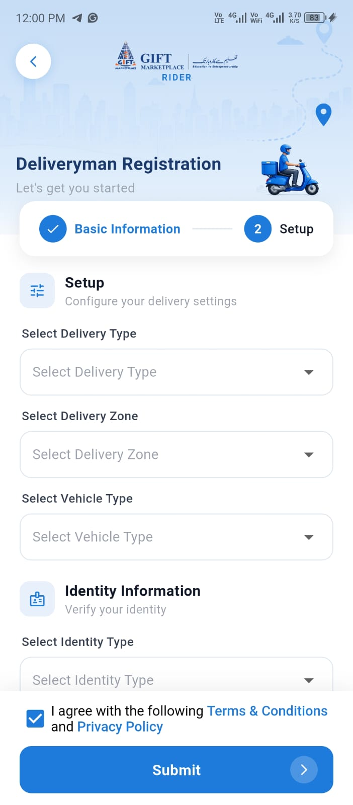
Registration - Delivery and identity setup
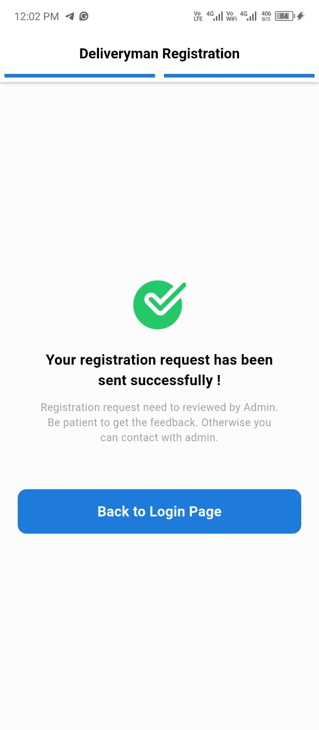
Registration submitted for administrator review

3.2 Sign in and recover a password
After an administrator approves the rider account, use the registered mobile number and password to sign in. If the password is forgotten, verify the registered number by OTP and create a new password.

3.2.1 Sign in to Marketplace Rider
Goal: Open the rider dashboard using an approved delivery-rider account.
Prerequisites: An approved rider account, the registered mobile number, the account password, and an internet connection.
Procedure
- Open Marketplace Rider.
- On the Welcome Back screen, confirm that the country code is +92.
- Enter the registered mobile number without the country code.
- Enter the account password. Tap the eye icon only if you need to check the characters.
- Optional: select Remember me only on a private, trusted phone.
- Tap Log In.
Expected outcome: The app opens the rider Home dashboard.

If unsuccessful: If the app shows “Incorrect credential please try again,” check the mobile number and password and try again. If the password is not known, follow Section 3.2.2.

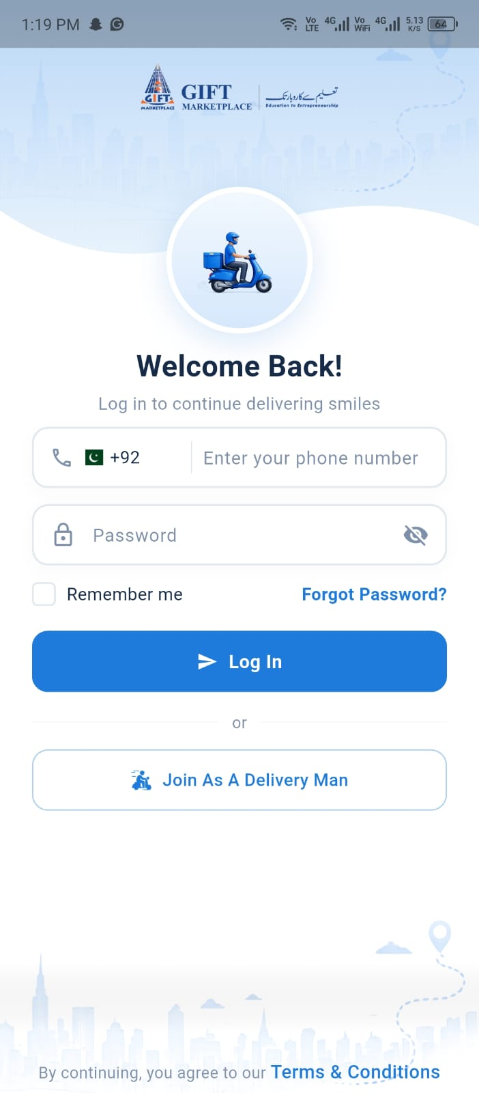
Figure 1. Marketplace Rider login screen

3.2.2 Reset a forgotten password
Goal: Regain access by verifying the registered mobile number and setting a new password.
Prerequisites: Access to the registered mobile number so you can receive the six-digit OTP, plus an internet connection.
Procedure
- On the login screen, tap Forgot Password?
- Enter the registered mobile number without +92 or any other country code.
- Tap Next. The OTP Verification screen opens and a six-digit code is sent to the registered number.
- Enter the latest six-digit OTP.
- Tap Verify.
- If the code does not arrive, wait until the Resend countdown finishes, then tap Resend. The app confirms “Resend code successful.” Use only the newest code received.
- On the Reset Password screen, enter a new password containing at least eight characters, one number, one uppercase letter, one lowercase letter, and one special character.
- Enter the same password in Confirm Password.
- Tap Done, return to the login screen, and sign in with the new password.
Expected outcome: The password is reset and the rider can sign in with the new password.

Common messages and recovery
- “Invalid phone number. Please enter your phone number without country code” enter the complete local mobile number only; do not type country code.
- “Phone number not found!” verify the number.
- “Incorrect OTP” enter the latest six-digit code or request a new one after the countdown ends.
- If Done is unavailable, confirm that every password requirement is satisfied and that both password entries match exactly.
Security note: Never share a password or OTP. Do not include real phone numbers, passwords, or OTPs in screenshots used in the published manual.

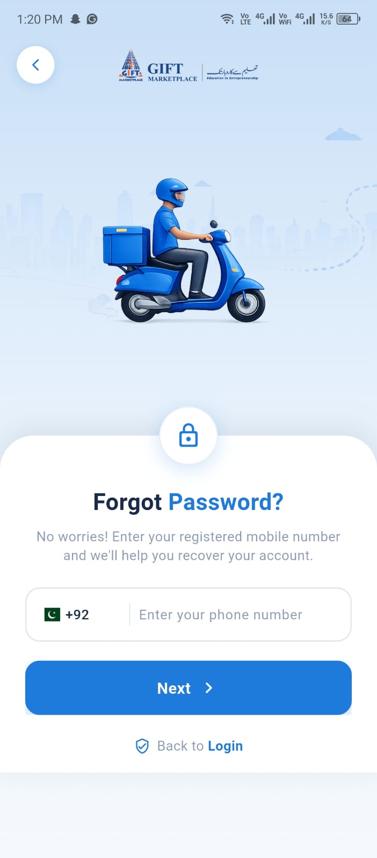
Figure 2. Forgot Password screen
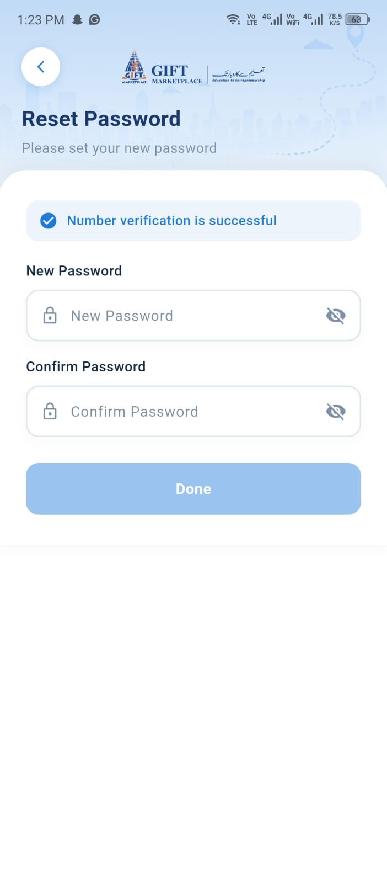
Figure 3. Reset Password screen after successful number verification
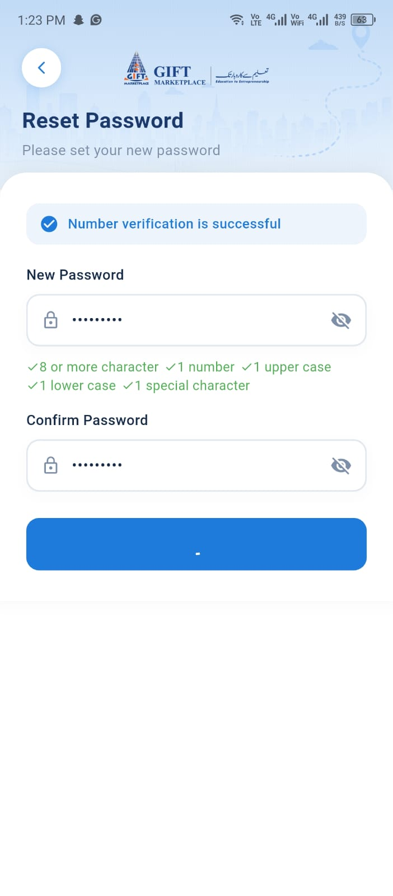
Figure 4. Password requirements displayed after entry

3.3 Navigate the app
Area | Purpose
Home | View conversations, notifications, and order totals. Freelance riders also see account balance, earnings, and account shortcuts; salary-based riders see order totals without the financial card.
Request | View incoming request cards, map locations, order details, and accept or ignore controls. (Only for freelance rider)
Orders | View running orders, order states, return states, and order history.
Profile | Manage availability, profile information, password, language, notifications, withdrawal methods, policies, account deletion, and logout.
Home dashboards by rider type
After sign-in, Home provides quick access to conversations, notifications, order totals, and the four primary navigation tabs. The financial information shown on Home depends on the rider type assigned to the account.
- Freelance rider: Home includes an account card with Available Balance, today's amount, My Earning, and My Account controls, followed by Today's Orders, This Week Orders, and Total Orders.
- Salary-based rider: Home displays Today's Orders, This Week Orders, and Total Orders. The account balance and earnings card is not displayed.
- A value of 0 means that the current rider account has no recorded orders for that period. A badge on Request indicates pending requests that require review.
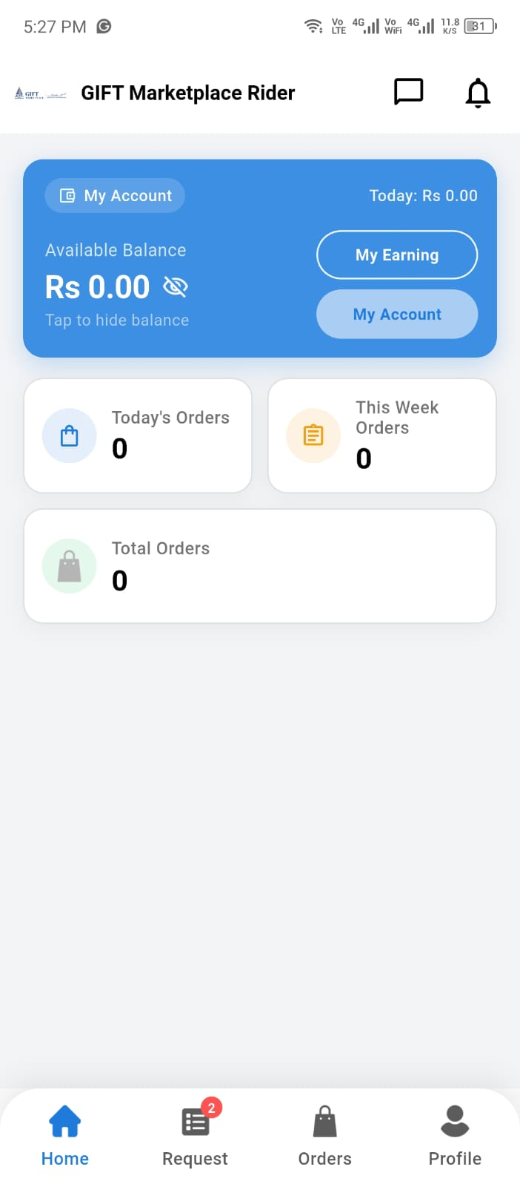 | 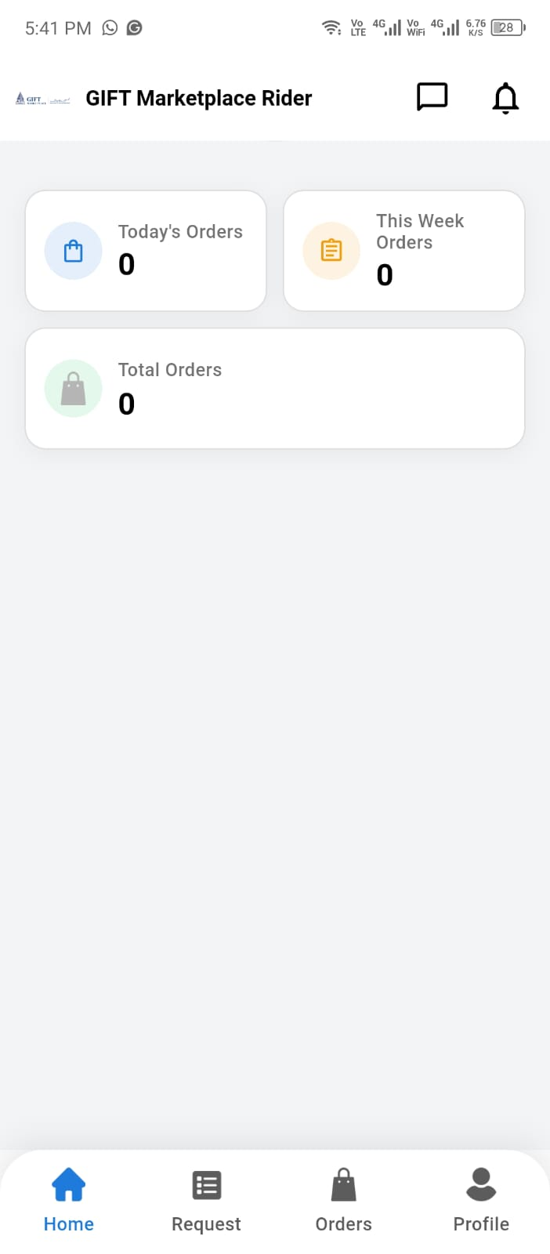
Figure 5. Freelance rider Home dashboard | Figure 6. Salary-based rider Home dashboard

4. Orders and Delivery Procedures

4.1 Review and respond to an incoming request
The Request tab lists incoming delivery requests that the rider can inspect before deciding whether to accept or ignore them. Review the pickup, destination, item, payment, and distance information before responding.
Goal: Review an incoming request and make an informed accept or ignore decision.
Prerequisites: The rider is signed in, available to receive requests, and connected to the internet.

4.1.1 Review the request card
Procedure
- Tap Request in the bottom navigation. A badge may show the number of pending requests.
- Review each request card before selecting an action.
- Check the store or vendor, item count, pickup address, request age, and distance from your current location.
- Check the delivery destination, order amount, and payment method, such as Cash on Delivery (COD).
- Use View on map or Order Details when more information is required.
- Select Accept only when you can complete the request. Select Ignore when you do not want to take it.
Information shown on a request card
- Store or vendor name and logo.
- Number of items and pickup address.
- Elapsed time since the request was created.
- Approximate distance from the rider.
- Delivery destination and View on map control.
- Order Details control.
- Order amount, payment method, Ignore, and Accept controls.
Expected outcome: The rider understands the request and can open its map or details, accept it, or ignore it.

4.1.2 View the map and order details
View the order location
- On a request card, tap View on map.
- Review the map markers and the approximate distance information.
- Review the amount and payment method shown at the bottom of the screen.
- Tap Accept or Ignore if ready, or use the back arrow to return to the request list.
Caution: Map positions and displayed distances may be approximate. Confirm the authorized pickup and delivery addresses before traveling.

View complete order information
- On a request card, tap Order Details.
- Review the order ID, schedule, payment method, item count, and payment status.
- Review each item's name, quantity, price, unit, and available variation information.
- Review the store details and the customer delivery information.
- Review the billing summary, including item price, discount, delivery fee, rider tip, and total amount when displayed.
- Use Chat, Call, or Direction only for the active authorized order and only when operationally necessary.
Review Required: The supplied test details screen also displayed Handover and Return Progress information. Confirm whether these sections normally appear before a request is accepted, and document the correct behavior for version 3.7.

4.1.3 Accept an incoming request
Procedure
- Review the request card, map, and order details.
- Tap Accept.
- When the confirmation dialog asks “Are you sure to accept?” and “You want to accept this order?”, select Yes to confirm.
- Select No to close the dialog without confirming acceptance.
- After selecting Yes, open Orders and verify that the request appears as an assigned order before traveling.
Expected outcome: The app processes the acceptance and the rider verifies the assigned order in Orders.

If unsuccessful: Refresh the request list and check the internet connection. Do not travel until the order appears as assigned in Orders. Contact the administrator if the request state is unclear.

4.1.4 Ignore an incoming request
Procedure
- Review the request and confirm that you do not want to accept it.
- Tap Ignore.
- When the confirmation dialog asks “Are you sure to ignore?” and “You want to ignore this order?”, select Yes to confirm.
- Select No to close the dialog without confirming the ignore action.
- Return to the Request tab and continue reviewing other available requests.
Review Required: Confirm whether an ignored request disappears permanently, can return later, affects rider metrics, or requires an ignore reason. The supplied screenshots do not show the result after selecting Yes.

Data protection: Treat customer names, addresses, order numbers, contact details, and map locations as confidential. Use only approved, redacted screenshots in training or published manuals.

4.2 Pick up an assigned order
Goal: Confirm that the rider has collected the correct order from the store or warehouse.
Prerequisites: An assigned order with accessible store details and an authorized pickup action.
Procedure
- Open Orders and select the assigned order.
- Review the order ID, store details, item information, payment method, and billing information.
- Use Direction to navigate to the store or warehouse. Use Chat or Call only when clarification is required.
- Confirm the correct item, quantity, and variation with the store.
- Use Swipe to pick up order only after the product has physically been handed to you.
- Verify that the order appears in Orders > Running Orders under Picked Up before leaving the pickup location.
Expected outcome: The app records the pickup and moves the order into a delivery state.

If unsuccessful: Do not confirm pickup without the product. Preserve the current screen and contact the store or administrator if the item, order, or status is incorrect.

4.3 Deliver an order
Goal: Deliver the assigned product to the correct customer and record the result.
Prerequisites: A picked-up order, the correct product, customer destination, and any required payment or verification information.
Procedure
- In Orders > Running Orders, open the order under Picked Up.
- Review the customer, destination, payment method, payment status, item information, and billing summary.
- Use Direction to navigate to the authorized customer location. Use Chat or Call when coordination is required.
- When you reach the delivery city or service area, tap Arrived in City. The order moves to the Arrived in City status.
- Open the Arrived in City order and tap Start Delivery Attempt. The app records Attempt #1 - Started, and the running-order status changes to Out for Delivery.
- The tested build displays Attempt 1 of 3. Do not start repeated attempts unless permitted by the approved delivery-attempt policy.
- Confirm the recipient and complete any approved customer-verification requirement before handing over the product.
- For a successful handover, tap Delivered. Review the displayed order amount and tap OK only when the amount is correct.
- For a COD order, collect the full amount displayed in the Collect money from customer message, then tap OK.
- Verify that the order status is Delivered, the payment status is Paid for COD, and Delivery Attempt History shows the attempt as Delivered.
- If delivery is unsuccessful, tap Attempt Failed only for an approved reason and follow the configured retry or escalation procedure.
Expected outcome: The order is marked Delivered, the attempt result and timestamp are recorded, and a completed COD order displays Paid after the rider confirms cash collection.

If unsuccessful: Record a failed attempt only for an approved reason. Do not guess the reason or repeatedly retry. Follow the configured attempt limit and escalate when the limit is reached.

Review Required: Confirm the post-acceptance and post-ignore results, approved customer-verification or proof-of-delivery method, failed-attempt reasons, cancellation flow, and the organizational policy for the three displayed delivery attempts.

4.4 View running orders and history
- Use Running Orders to view active work grouped by status, including Picked Up, Arrived in City, and Out for Delivery.
- Use History to review completed deliveries and available refund or return records.
- Open an order card to review its status, contact controls, delivery-attempt history, payment status, and billing summary.

5. Return Procedures

5.1 Pick up a customer return
Goal: Collect an approved return from the customer.
Prerequisites: An order in Return Pickup Assigned status.
Procedure
- Open Orders and select the Return Pickup Assigned order.
- Review the item, customer pickup location, payment information, and return progress.
- Use Direction to travel to the customer pickup address.
- Use Chat or Call when coordination is required.
- Confirm that the returned item matches the order.
- Select Pick Up from Customer only after receiving the product.
- Verify the next return destination and status.
Expected outcome: The return pickup is recorded and the order moves to a vendor, store, or platform return stage.

If unsuccessful: Do not accept an unrelated or visibly incorrect product without approved guidance. Contact the administrator when the item or return destination is unclear.

5.2 Return a product to a vendor or store
Goal: Deliver a collected return to the vendor or store and obtain system confirmation.
Prerequisites: A return assigned to the vendor/store and the collected product.
Procedure
- Open the return order and confirm Go to vendor/store address.
- Use Direction to travel to the listed destination.
- Select Start Vendor Return when you are ready to perform the handover.
- Give the correct product to the authorized vendor representative.
- Ask the vendor to select Confirm Received in the vendor application.
- Wait for the app to confirm completion.
- If the handover fails, use Vendor Attempt Failed only in accordance with the approved retry policy.
Expected outcome: The vendor confirms receipt and the return becomes complete or moves to the next resolved state.

If unsuccessful: Keep the product secure and contact the administrator if the vendor cannot confirm receipt or the configured attempt limit is reached.

5.3 Return a product to the platform
Goal: Deliver a collected return to the platform and wait for administrator confirmation.
Prerequisites: A return in Return Out for Platform or Return Awaiting Platform Confirm status.
Procedure
- Open the return order and confirm Go to platform address.
- Travel to the listed platform destination.
- Select Start Platform Delivery when beginning the handover.
- Hand the correct item to the authorized platform representative.
- Wait for administrator confirmation.
- Verify that the return status progresses to completion.
Expected outcome: The platform confirms receipt and the return is completed or resolved.

If unsuccessful: Do not leave the product without an authorized handover. Contact the administrator if confirmation does not appear.

6. Communication and Notifications

6.1 Conversations
The Conversation area can organize messages under Customer, Store, and Admin tabs. A conversation supports text, emoji, image/file attachment, and sending controls where enabled.
- Use customer or store conversations only for the active delivery or return.
- Use the Admin conversation for operational assistance when available.
- Do not send passwords, identity documents, payment credentials, or unrelated personal information.
- Attach only approved, redacted evidence required to resolve the issue.

6.2 Notifications
Use the notification icon to review available alerts. System notification and Background notification can be managed from Profile. Keep delivery notifications enabled when required by company policy.

7. Profile and Preferences

7.1 Availability and profile
- Use Online Status to manage delivery availability.
- Edit Profile can update first name, last name, email, and profile picture.
- The captured interface marks the phone number as non-changeable.
- Change Password requires a new password and confirmation.
- Dark Mode changes the app theme.

7.2 Language
The captured language selector provides English, Arabic, Spanish, and Bengali.
- Open Profile.
- Select Language.
- Choose the required language.
- Select Update.
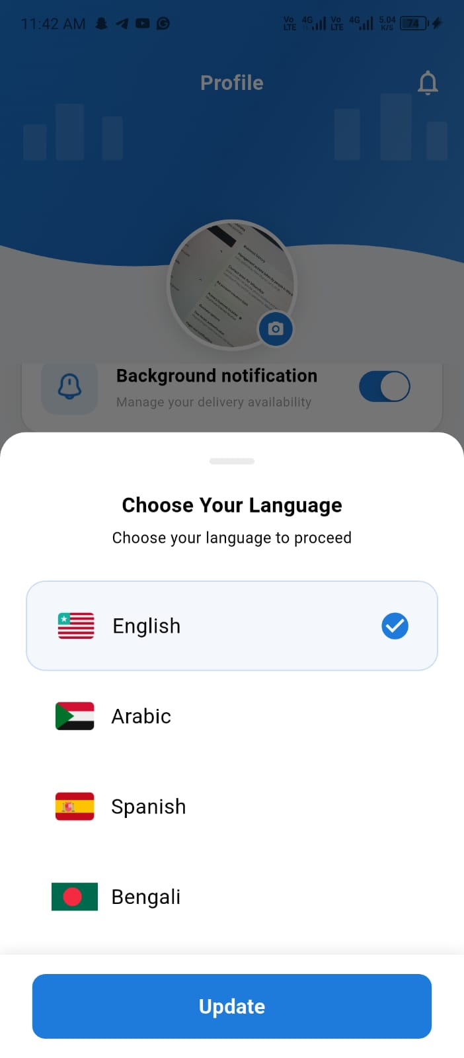
Language selection

7.3 Withdrawal methods
Withdraw Method allows the rider to add and manage withdrawal information. Captured options include JazzCash and Easypaisa Manual Payment. Existing methods may be marked as default, edited, or deleted.
- Open Profile and select Withdraw Method.
- Select Add Withdraw Info or the plus button.
- Select the payment method.
- Enter the required account information.
- Review the details and select Add Method.
Caution: Verify the account holder and account details before saving. Do not include real payment data in training screenshots.

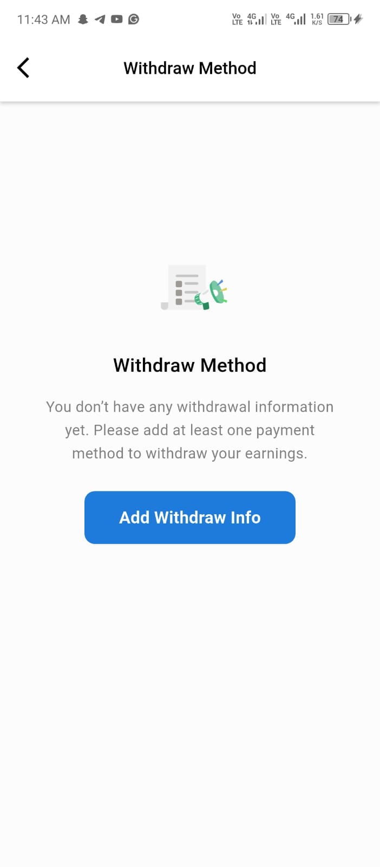
Withdrawal method before payment information is added

7.4 Delete account and logout
- Delete Account displays a confirmation warning that account information will be removed. Confirm the organizational deletion and recovery policy before using it.
- Logout displays a confirmation dialog. Select Yes only when you intend to end the current session.

8. Wallet and Earnings

8.1 Wallet overview
My Account provides Wallet Overview and My Point areas. Wallet Overview can display Payable Balance, Withdrawable Balance, withdrawal history, payment history, wallet earnings, pending withdrawal, total withdrawn, and cash in hand.

8.2 Adjust payments
Financial caution: Adjust Payments changes the Cash in Hand balance and Withdrawable Amount. Confirm the cash figure and follow the approved reconciliation process before selecting OK.

8.3 Review earnings
- From Home, select My Earning.
- Review Total Earning and Delivery Fee Earned.
- Select Order, Referral, or Loyalty Point as applicable.
- Use the filter control to select a reporting period.
- Open an earning entry to review its amount, order ID, payment method, delivery fee, delivery tips, and total.
The My Point screen in the supplied build states that the loyalty program is temporarily paused. Confirm whether this feature should appear in the published version 3.7 manual.

9. Interface and Status Reference

9.1 Primary controls
Control | Purpose | Important condition
Chat | Open an authorized conversation | Use only for the related order or support issue.
Call | Call the listed participant | Use only when operationally required.
Direction | Open navigation to the listed location | Confirm the destination before travelling.
Swipe to pick up order | Confirm physical pickup | Use only after receiving the correct product.
Pick Up from Customer | Confirm return pickup | Use only after collecting the approved return.
Start Vendor Return | Begin vendor-return handover | Vendor confirmation is required to complete.
Start Platform Delivery | Begin platform-return handover | Administrator confirmation may be required.
Adjust Payments | Reconcile cash and withdrawable balance | Financially sensitive; follow approved procedure.
Arrived in City | Record arrival in the delivery city or service area | Use only after reaching the appropriate delivery area.
Start Delivery Attempt | Begin a recorded customer-delivery attempt | The tested build displays the attempt number and limit.
Attempt Failed | Record that the current attempt was unsuccessful | Use only for an approved reason and follow the retry policy.
Delivered | Begin successful delivery completion | Confirm the handover and COD amount before finalizing.

9.2 Important statuses
Status | Meaning | Rider action
Picked Up | The order was collected from the source. | Travel to the authorized delivery destination.
Handover | The order is in a customer-delivery stage. | Complete the approved delivery attempt.
Delivered | The delivery result was recorded successfully. | Verify history and payment information.
Return Pickup Assigned | A customer return is assigned for pickup. | Travel to the customer and collect the approved item.
Return Out for Vendor | A return must be taken to the vendor/store. | Complete the vendor handover and obtain confirmation.
Return Out for Platform | A return must be taken to the platform. | Complete the platform handover.
Return Awaiting Platform Confirm | Platform receipt is waiting for confirmation. | Wait or contact the administrator if delayed.
Refund Requested / Refunded / Refund Resolved | A refund is at the indicated stage. | Review the order; do not alter the state without authority.
Arrived in City | The rider recorded arrival in the delivery city or service area. | Open the order and start the delivery attempt when ready.
Out for Delivery | A customer-delivery attempt has started. | Navigate to the customer and record either Delivered or Attempt Failed.

10. Security and Data Handling
- Use only your assigned rider account and device.
- Keep passwords, OTPs, identity documents, payment details, and recovery information private.
- Verify the customer, store, item, destination, payment method, and payment status before completing an action.
- Use customer names, addresses, phone numbers, and conversations only for the authorized delivery.
- Do not store customer or identity screenshots in personal galleries or unapproved messaging services.
- Use sample or redacted information in manuals, training, and support evidence.
- Report unexpected access, data exposure, payment discrepancies, or suspicious activity immediately.
Warning: Never share credentials, identity documents, customer information, wallet details, or payment-account information with an unauthorized person.

11. Troubleshooting and Support

11.1 Diagnostic checklist
- Record the exact message, time, order ID, status, and action attempted.
- Confirm the internet connection and that the correct rider account is active.
- Verify the order, participant, destination, payment method, and current state.
- Preserve unsaved information and avoid repeating an action that could create duplicate records.
- Use the Admin conversation or the approved organizational support channel.
- Attach only approved, redacted screenshots or evidence.

11.2 Common issues
Issue | Possible cause | Safe action
Registration remains pending | Administrator review is incomplete. | Wait for feedback and contact the designated administrator.
No order request available | No current request is assigned or available. | Remain online if required and wait for a notification.
Required action is missing | Wrong status, incomplete prior step, or insufficient permission. | Reopen the order, confirm its state, and contact the administrator.
Direction or contact control fails | Device permission, network, or participant information issue. | Check the connection and approved device permissions; do not use unapproved contact details.
Vendor/platform confirmation is delayed | Receiving party has not confirmed the handover. | Keep the product secure and contact the authorized administrator.
Cash or balance appears incorrect | Pending transaction, reconciliation, or payment issue. | Do not adjust blindly; preserve evidence and follow the approved financial process.

11.3 Support information
Use the in-app Admin conversation when available or contact the official support channel assigned by the organization. Include the rider role, app version 3.7, order ID where applicable, date and time, current status, exact message, and expected result.
Review Required: Insert the approved support team name, portal, email, phone number, operating hours, and emergency/security channel.

Appendix A. Glossary
Term | Meaning
COD | Cash on Delivery.
Delivery attempt | A recorded attempt to complete a delivery or return handover.
Handover | The delivery stage in which the rider transfers an item to the intended recipient.
Payable Balance | A balance displayed by the wallet; confirm the organizational financial definition.
Withdrawable Balance | The amount currently shown as eligible for withdrawal, subject to organizational rules.
Return Pickup Assigned | A customer return assigned to the rider for collection.
Return Out for Vendor | A collected return being delivered to the vendor or store.
Return Out for Platform | A collected return being delivered to a platform location.

Appendix B. Pre-publication Review Checklist
- Confirm document owner, approver, release date, classification, legal text, and official support contacts.
- Confirm supported devices, operating systems, network requirements, and mobile permissions.
- Confirm the tested login, OTP, and recovery procedures; add rejected-registration, session-timeout, and lockout procedures.
- Add approved screenshots for order request, acceptance/rejection, successful delivery, failed attempt, COD, proof of delivery, and withdrawal request.
- Confirm delivery and return attempt limits and all status definitions.
- Confirm customer verification, COD, cancellation, refund, deletion, wallet, and cash-adjustment rules.
- Replace or redact every screenshot containing names, phone numbers, email, identity details, addresses, balances, or account information.
- Have representative delivery riders test every critical procedure.
- Update the table of contents and all fields in Word.
- Obtain product, security, privacy, finance, support, and team-lead approval before publication.

